Ocean Graham

Abstract

[Draw your reader in with an engaging abstract. It is typically a short summary of the document.   
When you’re ready to add your content, just click here and start typing.]

402it - information security

Risk Assessment Report



Table of Contents

Table of Figures 1

Introduction 2

ISo/IEC 27001 3

Nist SP 800-30 4

Risk identification 5

Asset identification 5

Risk analysis and evaluation 6

References 6

# Table of Figures

Figure 1 - CIA Triangle 3

Figure 2 - ISO/IEC 27001 Risk Matrix 4

Figure 3 - Risk Calculation 5

Figure 4 - Asset Table 7

Figure 5 - Asset Vulnerabilities Table 9

Figure 6 - Threat Event and Risk Table 13

Figure 7 - Mitigation Table 16

Figure 8 - Metasploitable IP check 18

Figure 9 - Nmap IP scan 18

Figure 10 – OS scan 19

Figure 11 - Aggressive scan 1 20

Figure 12 - Aggressive scan 2 20

Figure 13 - Aggressive scan 3 21

Figure 14 - Service Versions scan 21

Figure 15 - Vulnerability scan 1 22

Figure 16 - Vulnerability scan 2 22

Figure 17 - Vulnerability scan 3 23

Figure 18 - Vulnerability scan 4 23

Figure 19 - Vulnerability scan 5 24

Figure 20 - Vulnerability scan 6 24

Figure 21 - Vulnerability scan 7 25

Figure 22 - Vulnerability scan 8 25

402IT – Information security

# Introduction

In this coursework the author will demonstrate a high degree of understanding of information security and the critical role in plays in guarding information from threats.

## What is information security?

Information security (InfoSec) is the protection of both physical and digital information against unauthorised access, disclosure and disruption/alteration. (IBM, 2024, What is information security?) The prevalence and rise of cyber threats (such as DoS, Malware, SQL Injections and Phishing) has created threats to the confidentiality, integrity and availability (CIA) of a person’s or organization's information. (Calder & Watkins, 2024)

## Principles of Information Security

InfoSec works under the principles of the CIA triangle (Confidentiality, Integrity & Availability), these principles are used to gauge the degree of InfoSec the information has. The three parts entail:

1. Confidentiality – preventing unauthorized access and reading of private information. (Stamp, 2011)
2. 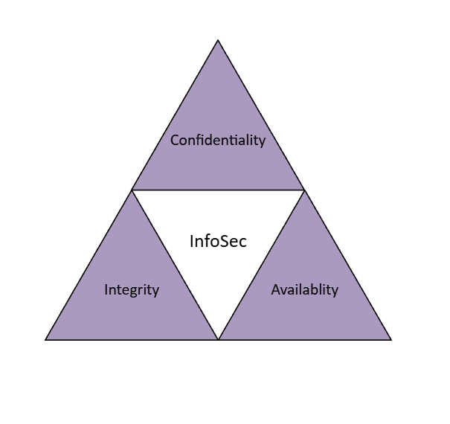Integrity – preventing/ detecting unauthorized access from altering/tampering data, making sure this data is authentic and reliable. (Stamp, 2011)

Figure 1 - CIA Triangle

1. Availability – making data available to the required personnel when needed to allow an organisation to function as it should. (Fortinet, 2023)

## ISo/IEC 27001 & 27005

The ISO/IEC 27001 and 27005 is the most used standard of certification (a credential that validates a company’s proficiency in an Information Security Management System (ISMS)) within the InfoSec field. ISO/IEC 27001 provides companies with guidance for improving an ISMS, ensuring high degree of quality to safety and security, providing a centralised framework, respond to evolving risks and reduce vulnerability to cyber-attacks. (ISO, 2022) ISO/IEC 27001 contains 5 primary steps of implementation:

1. Define Scope and Objectives
2. Conduct Risk Assessment
3. Implement Security Controls
4. Monitor and Review Performance
5. Continuous Reiteration and Improvement

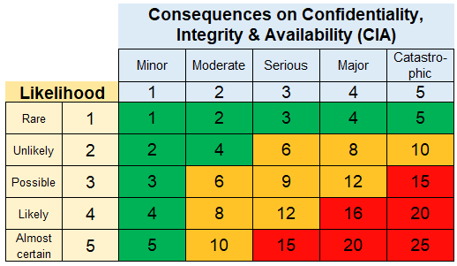ISO/IEC 27001 also gauges risks of events through a risk assessment, calculated via Likelihood times by Impact/Consequences relating to the CIA Triangle.

Figure 2 - ISO/IEC 27001 Risk Matrix

Source - (Pope, 2023)

The reason other certifications and standards exist, compared to the seemingly primarily regarded ISO/IEC 27001, is due to the problem that comes to ISO/IEC 27001. ISO/IEC 27001 standard is a very difficult and lengthy pursuit of the certification. The standard requires significant time and financial resources into achieving the relevant certification, that whilst large companies can afford, smaller companies may not hold the capabilities to perform the demands ISO/IEC 27001 requires. It also holds the risk of companies focusing on complying with requirements over actual security needs.

## Nist SP 800-30

The NIST SP 800-30 is an alternative to ISO/IEC 27001, developed by the US National Institute of Standards and Technology. NIST SP 800-30 is a risk assessment guideline for conducting risk assessments and managements of systems and organisations. (NIST, 2012) The process of NIST SP 800-30 risk assessment preparation according to the (NIST, 2012) documentation follows:

1. Identify Purpose – Identify the purpose via the information that is assessed and the expected outcome.
2. Identify Scope – Identify the scope of the assessment in scale to the organisation’s capabilities.
3. Identify Assumptions and Constraints – Make clear the restrictions and limits of the assessment, what is acceptable.
4. Identify Information Sources – Identify the threats, vulnerabilities and impacts and what is the source of these.
5. Identify Risk Model and Analytic Approach – Identify the risk model and approach to be used in the assessment.

NIST SP 800-30 documentation (NIST, 2012) also elaborates the 6 steps “tasks” to conducting a risk assessment following NIST SP 800-30 guidelines:

1. Identify Threat Sources
2. Identify Threat Events
3. Identify Vulnerabilities
4. Determine Likelihood of Threat Event
5. Determine the Negative Impact of Threat Sources
6. Determine Risks via the calculation (Likelihood x Impact)

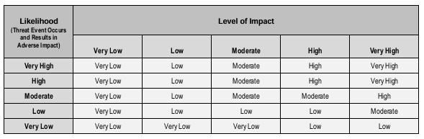Figure 3 - Risk Calculation

Source- (NIST, 2012)

Just as with ISO/IEC 27001, the NIST SP 800 series (therefore NIST SP 800-30) can be resource intensive, however due to the lack of financial demand, it allows smaller companies to have better chances to implement this standard.

# Methodology of Report

This report will be conducted via online research on vulnerabilities within the labelled systems and services within the brief of the New England Hospital. The primary source of information being the Common Vulnerabilities and Exposures (CVE) website which publicly displays and elaborates on computer system’s security faults/flaws. The CVE site will allow the author to find potential threats and gaps within the New England Hospital’s in-use systems to find threats and create a risk assessment.

An array of Virtual Machines (Via OracleVM) have also been used to simulate the hospitals systems. Allowing the Simulator to penetrate the systems to help identify the vulnerabilities and provide evidence to threats of the systems that are in use. Kali Linux was utilised in accordance with the system environments due to its modularity and variety in tools that can be utilised.

# Asset identification

|  |  |  |
| --- | --- | --- |
| Category | Asset | Vulnerability |
| Software | -Windows Server 2016  -Windows Server 2019  -Windows 8  - Windows 10  -Legacy Windows XP  - Linux based SQL database servers  -J2EE Glass Fish application servers  -Web Application Server  -Online Web Services via the Internet  -Building-wide Local Area Network (LAN) | -Risk of system vulnerabilities allowing malicious attacks (malware, spoofing, reconnaissance, scanning, SQL Injections)  -Exploit poorly configured /unauthorised information systems exposed to the internet  -Disruptions via Network, Hardware or other errors  -Loss of sensitive information  -Lack of Support due to outdated older systems |
| Hardware | -Java Resource Adapter Architecture  -Workstations (Working on Windows 8 & 10)  -Removable Media (e.g. USB’s)  -Laptops and Mobile devices | -Insert malware into organisational hardware  -Environmental threats (Fire, Flooding, Hurricanes)  -Loss of devices via theft or damage  -Malfunctions due to deliberate actions or other causes |
| Data | -Patients Databases  -Communication Databases  -Financial Databases  -Staff Databases  -Communications Databases  -Passwords & Logins | -Threat to CIA Triangle due to security breaches of Hardware or Software  -Unauthorised access  -Spoofing (tampering with data)  -Threats of brute-force attacks to access accounts |
| Structural | -Staff  -Facilities | -Gossip sharing private information  -Poor security logins due to staff  -Risk of leaving systems unlocked and unsupervised  -Unauthorised access into Private locations |

Figure 4 - Asset Table

## Specific Assset Vulnerabilities

The table below presents more in-detail vulnerabilities (according to the CVE) for many of the software assets displayed.

|  |  |  |
| --- | --- | --- |
| Category | Asset | Vulnerability |
| Software | Windows Server 2016 | -End of Life (No more support)  -Remote desktop client allows attackers to execute code over a network. (**CVE-2025-26645**)  -External control of file names & paths via New Technology LAN Manager (NTLM) allowing spoofing (fraud via forgery) over network. (**CVE-2025-24996**)  - Windows Kernal memory info disclosure Vulnerability. (**CVE-2025-21323**) |
| Software | Windows Server 2019 | -End of Life (No more support)  -Remote desktop client allows attackers to execute code over a network. (**CVE-2025-26645**)  -External control of file names & paths via New Technology LAN Manager (NTLM) allowing spoofing (fraud via forgery) over network. (**CVE-2025-24996**)  -Windows Kernal memory info disclosure Vulnerability. (**CVE-2025-21323**) |
| Software | Windows Workstation 8  (Workstation working on Windows 8) | -End of Life (No more support)  -Microsoft Surface Security feature bypass vulnerability. (**CVE-2025-21194**)  **-**A kernel-mode driver in Windows 8 allows an Elevation of Privilege Vulnerability when it fails to properly handle objects in memory. (**CVE-2017-8552**) |
| Software | Windows Workstation 10  (Workstation working on Windows 10) | -Relative path traversal in Remote Desktop Client allows unauthorised attacker to execute code over network. (**CVE-2025-26645**)  **-**Heap-based buffer overflow in Windows Routing and Remote Access Service (RRAS) allows an unauthorised attacker to execute code over a network. (**CVE-2025-24051**) |
| Software | Legacy Windows XP | -End of Life (No more support)  -SQL injection in View User Profile in MicroWorld eScan Management Console allows remote attacker to dump entire database and gain windows XP command shell to perform code execution on database. (**CVE-2023-31702**) |
| Software | Linux based SQL database servers | -IBM Db2 for Linux is vulnerable to a Denial of Service (DoS), under specified non default configurations as the server may crash when using a specially crafted SQL statement by authenticated user.  (**CVE-2024-31882**) |
| Software | J2EE Glass Fish application servers | -SQL injection vulnerability in the UDDI Server allows remote attackers to execute Structured Query Language (SQL) commands. (**CVE-2016-2386**)  -Vulnerability in the Oracle Containers allows remote attackers to affect integrity. (**CVE-2010-0070**) |
| Software | Building-wide Local Area Network (LAN) | -Cross Site Scripting vulnerability allows a remote attacker to escalate privileges via the menu interface of the member center of the background administrator. (**CVE-2025-25960**) |
| Hardware | Java Resource Adapter Architecture | -JNDI injection into JDBC driver, leading to remote code execution. (**CVE-2024-54660**) |

Figure 5 - Asset Vulnerabilities Table

# Risk identification

The table below follows the NIST SP 800-30 Scale (Figure 3) for Impact, Likelihood and Risk

|  |  |  |  |  |  |
| --- | --- | --- | --- | --- | --- |
| Asset | Threat Event | Vulnerability | Impact | Likelihood | Risk |
| Windows Server 2016 | Threat of spoofing via NTLM | Puts the Integrity of data within the server at risk due to the potential tampering of sensitive data, this is amplified due to this assets service being End of Life. | Very High | Very High | Very High |
| Windows Server 2019 | Threat of spoofing via NTLM | Puts the Integrity of data within the server at risk due to the potential tampering of sensitive data, this is amplified due to this assets service being End of Life. | Very High | Very High | Very High |
| Windows Workstation 8 | Threat of Unauthorised/Untrusted access of sensitive data due to kernel issue | Threatens Confidentiality of data as there is a threat of personnel with lake of Privilege seeing data, they don’t have clearance for.  Risk of Malicious insider exploiting fault, resulting in potential breach and spread of sensitive data. | Very High | High | High |
| Windows Workstation 10 | Threat of Heap-based buffer overflow attack in RRAS risking unauthorised access | Threatens Integrity and Confidentiality of data, this attack corrupting stored data in a way to allow attacker to overwrite structure, allowing access to read and/or alter sensitive data. | Very High | High | High |
| Legacy Windows XP | Threat of SQL injection allowing attacker to acquire database and access XP command shell | Threatens Confidentiality and Integrity, attacker gaining access to private information such as addresses, Identification, or billing accounts of patients and staff. Also potentially being able to alter information of system data through command shell. | Very High | Very High | Very High |
| Linux based SQL database servers | Threat of DoS due to attack or high traffic | Threatens Accessibility due to temporary loss of important data due to disruption caused by overwhelming of system (DoS). | Moderate | Moderate | Moderate |
| J2EE Glass Fish application server | Threat of SQL injection allowing attacker to execute SQL commands | Threatens Confidentiality, SQL commands allowing attacker to access private information such as addresses, Identification, or billing accounts of patients and staff. | Very High | Very High | Very High |
| Web application server | Threat of SQL injections | Threatens Confidentiality, SQL injections risking the sensitive data being breached and accessed by unauthorised personnel. |  |  |  |
| Online Web Services via the Internet | Threat of Phishing and Malware | Threatens systems, services and privacy due to malware damaging and disrupting systems. Phishing may also occur online by clicking an unsafe link, resulting in breaching of data security. | High | Very High | High |
| Building-wide Local Area Network | Threat of escalation of privileges | Threatens Confidentiality, attacker may escalate privileges of themselves or someone else to access priorly restricted data they lack the authorisation to access. | High | High | High |
| Java Resource Adapter Architecture | Threat of JNDI injection | Threatens Integrity, JNDI injections allowing attackers to add to/ alter text log messages and search for resources. | Very High | High | High |
| Workstation | Threat of:  -Out of Date Hardware.  -Easy to crack Passwords.  -Unsupervised open computers | Risks to Confidentiality and Integrity, the privacy of patient and staff information affected with varying degrees depending on whether the password was breached, or the computer was left open. This means personal private information can be accessed, altered and/or shared. | High | Very High | High |
| Removeable Media (e.g. USB’s) | Threat of installation of malicious software, or exportation of private information. | Threatens Confidentiality and Integrity: Access to USB ports may allow for the installation of malware which can be result in data loss, scanning or sharing. Alternatively, sensitive data may be taken from a computer via the USB ports resulting similarly in damage to Confidentiality | Very High | Moderate | Moderate |
| Staff | Threat of:  -Weak Passwords.  -Passwords or other sensitive data places in unsafe areas (easily at risk).  -Gossiping of sensitive information | Threatens Confidentiality,  Weak passwords or passwords written down result it threats to hardware breaching from unauthorised personnel. Gossiping of sensitive information may result in unauthorised malicious personnel acquiring sensitive important data. | High | Very High | High |

Figure 6 - Threat Event and Risk Table

# Risk analysis and evaluation

Due to the nature of business the organisation works upon, all field of resources (hardware, software, data) are of high importance and must uphold the CIA Triangle, therefore being prioritised and significantly affected by malicious attackers or other threats. As a result of this, any breach may result in catastrophic damage, giving reason to why the Impact of most assets threat events are ‘High’ to ‘Very High’, any breach most likely affecting all fields of the CIA Triangle.

Once again due to the very valuable, sensitive data, the likelihood of any most threats are ‘High’ to ‘Very High’. A hospital being a large scale organisation, can result in a high frequency of internal error, this having effects on the primarily the Confidentiality and Accessibility of sensitive data. There is also the threat of malicious internal and external attacks which is likely due to as said before, a hospital being a large scale organisation and holding high levels and volumes of sensitive, private and important data.

## Mitigation

Given the scale and importance of this organisation, mitigation strategies based on threat events and other potential risks.

|  |  |
| --- | --- |
| Threat Event | Mitigation Strategy |
| **Universal**  (Mitigation strategies for all Threat events) | -Develop organisational awareness, education and training for Info Security  -Monitor users and access locations  -Report system for Incidents  -Frequent scanning of systems for threats |
| SQL Injection | -Implement prepared statements (makes databases be able to distinguish between code and data: attacker cannot alter structure)  -Implement Validation and Sanitisation of inputs (makes system only accept and process safe data)  -Restrict database access (Access control – only verified users can access databases)  -Keep software up to date, upgrade End of Life software to newer systems |
| DoS / DDoS | -Attack detection (awareness via monitoring and analysis of traffic allows organisation to detect when they may be under a potential DoS attack)  -White & Black-listing IPs (restricting IP access via Access Control means only certain IPs (e.g. within only the UK or only authenticated IPs) may be accepted, rejecting potential illegitimate IPs)  -Limit traffic (limiting amount of traffic means that system cannot be overloaded by attack)  -Implement a Network firewall (protects and filters network from unwanted traffic) |
| JNDI Injection | -Restrict database access (Access control – only verified users can access databases)  -Implement a Web Application Firewall (protects server from external requests)  -Implement a VPN or other encryption process (encrypts data being sent, making data more discreet and useless for attacker)  -Keep software up to date, upgrade End of Life software to newer systems |
| Heap-based buffer overflow | -Utilise an interpreted language (source code is not directly translated into machine code, not susceptible to these attacks)  -Utilise Compilers (can identify unsafe functions or errors) |
| Phishing | -Implement Antivirus software  -Keep network in segments (if a part is breached, if segmented, not all data is breached)  -Implement a two-factor authentication (2FA) / External approval (any activity requires a secondary degree of authentication from the user, limiting/stopping access if data is acquired) |
| Escalation of Privilege | -Backup data frequently  -Implement a two-factor authentication (2FA) / External approval (any activity requires a secondary degree of authentication from the user, limiting/stopping access if data is acquired)  -Restrict database access (Access control – only authorised clearance users can access databases)  -Keep software up to date, upgrade End of Life software to newer systems |
| Malware    Examples:  -Spyware  -Trojan  -Ransomware | -Implement Antivirus software  -Backup data frequently  -Implement a Network Firewall (protects and filters network from unwanted traffic)  -Keep network in segments (if a part is breached, if segmented, not all data is breached)  -Keep software up to date, upgrade End of Life software to newer systems |
| Man-In-the-Middle  Potential results:  -Spoofing  -Reconnaissance | -Implement a Network Firewall (protects and filters network from unwanted traffic)  -Implement a two-factor authentication (2FA) / external approval (any activity requires a secondary degree of authentication from the user, limiting/stopping access if data is acquired)  -Implement a VPN or other encryption process (encrypts data being sent, making data more discreet and useless for attacker) |
| Brute-force | -Implement password policies to develop stronger secure passwords  -Limit login attempts  -White & Black-listing IPs (restricting IP access via Access Control means only certain IPs (e.g. within only the UK or only authenticated IPs) may be accepted, rejecting potential illegitimate IPs)  -Implement a two-factor authentication (2FA) / external approval (any activity requires a secondary degree of authentication from the user, limiting/stopping access if data is acquired)  -Password renewal with a set frequency (e.g. every 2 weeks, new password) |
| Verbal sharing of sensitive data (Gossip) | -Develop a ‘Consequence Management system’ for sharing of sensitive data |
| Weak Passwords | -Implement password policies to develop stronger secure passwords  -Implement a two-factor authentication (2FA) / external approval (any activity requires a secondary degree of authentication from the user, limiting/stopping access if data is acquired) |
| Passwords written down | -Develop a more secure system to contain passwords in that will result in less risk (Passwords will be written down due to misremembering or forgetting passwords, a strategy must compensate for this) |
| Unsupervised unlocked computers/systems | -Develop a ‘Consequence Management system’ for sharing of sensitive data  -Educate staff on how to lock screens/ what to do if they are leaving a organisational system unsupervised |

Figure 7 - Mitigation Table

# Penetration testing and Report

Penetration testing was conducted, This is defined by (Engebretson, 2011) as “a legal and authorized attempt to locate and successfully exploit computer systems for the purpose of making those systems more secure.” This helps identify, report and resolve the flaws in an ethical way. This is done to prevent any attacks via unethical ways from a real threat occurring by finding problems and solving them before they may be exploited in a malicious way.

The purpose of this testing in relation to the New England Hospital is to find the faults within their systems, providing them with a higher degree of security through the identification of the problems before an actual threat event occurs.

## Tool used

Oracle VirtualBox has been utilised to create virtual environments of the systems in use by New England Hospital (e.g. Windows 10, Windows XP, Windows and Linux Based Servers). A virtual machine was used due to the importance of the actual systems with all the data contained within. The virtual machines acting as a counter measure to prevent risk of CIA but still being able to explore vulnerabilities of the same types of systems.

Kali Linux was chosen as the operating system to be used for the penetration of the simulated hospital systems due to the open source nature of the system and the over 300 tools built into the operating system (Kali, n.d., ‘Kali Tools’), such as Nmap and Metasploit.

These Tools were used to perform 4 experiments to examine security of the simulated hospital systems:

1. Nmap
2. Metasploit
3. Phishing
4. SQL Map

### Nmap and metasploit

Nmap and Metasploit have been placed under the same heading due to the two experiments both using Nmap commands within their process.

Firstly, before the Nmap experiment is begun any penetration, we open our two systems (Metasploitable and Kali Linux) and use the command “nmap 10.100.1.4” on Kali Linux, this scans the IP input (Metasploitable IP) and checks which ports are open.

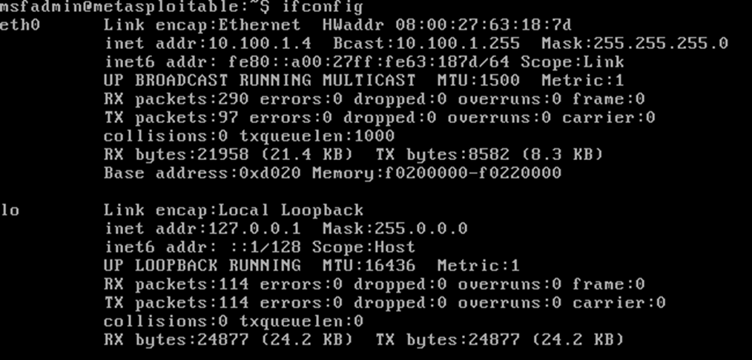

Figure 8 - Metasploitable IP check

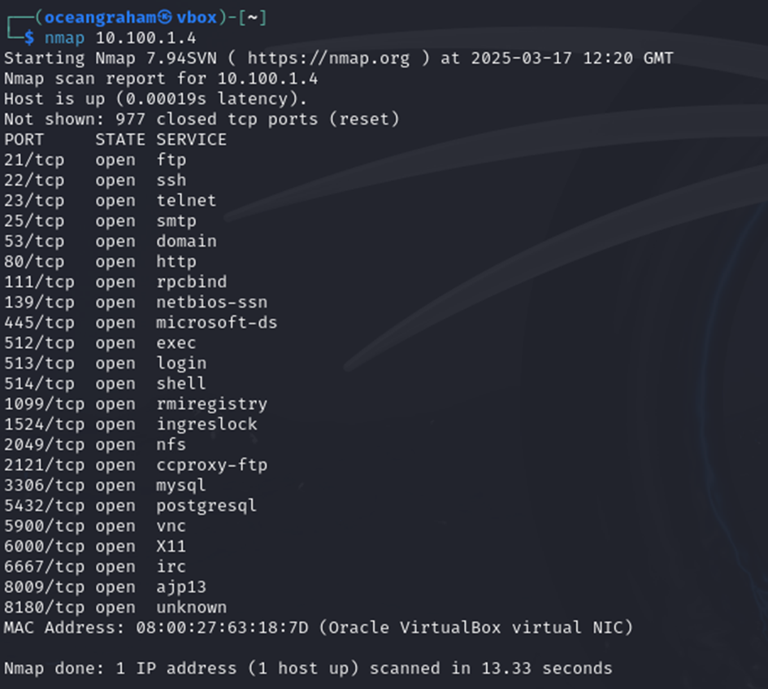

Figure 9 - Nmap IP scan

Next “nmap -O 10.100.1.4” is used to detect the operating system of the target. This is done by analysis of the IP stack behaviour, which helps identify the info to discern the operating system.

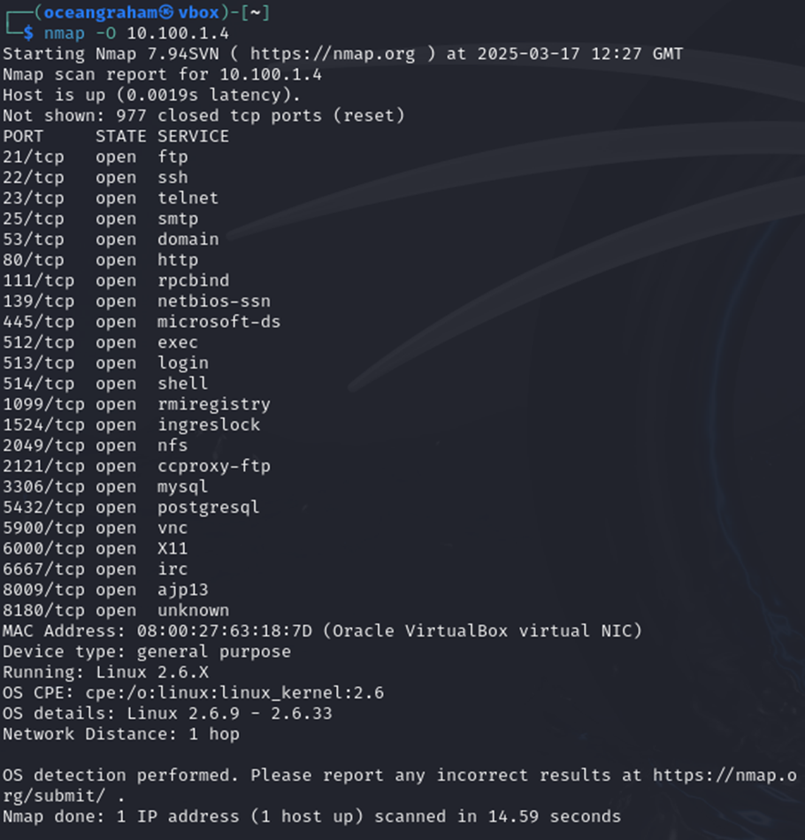

Figure 10 – OS scan

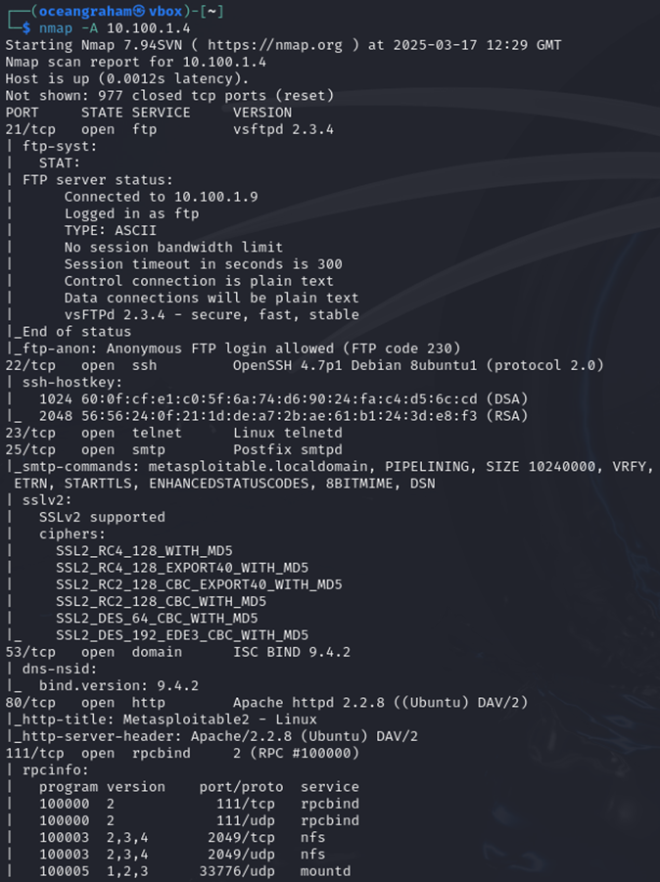Afterwards an aggressive scan is performed, this provides more in depth data however is more likely to be detected from the targets security. This aggressive scan includes operating systems, version, script scanning and traceroute. This command is done via “nmap -A 10.100.1.4”

Figure 11 - Aggressive scan 1

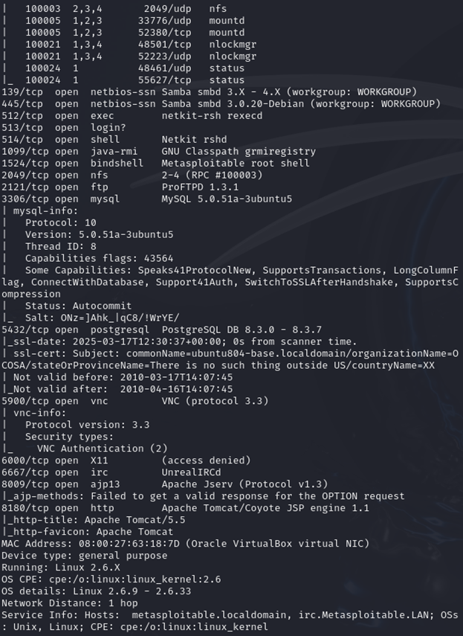

Figure 12 - Aggressive scan 2

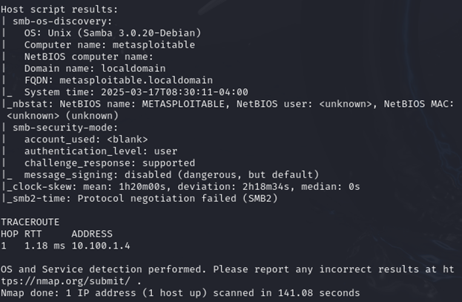

Figure 13 - Aggressive scan 3

Following this “nmap -sV 10.100.1.4” is used, this is done to identify the versions of services running on the open ports, this is valuable as it can help identify outdated/un-updated services which have vulnerabilities which can be found in the CVE and may hold vulnerabilities to exploit.

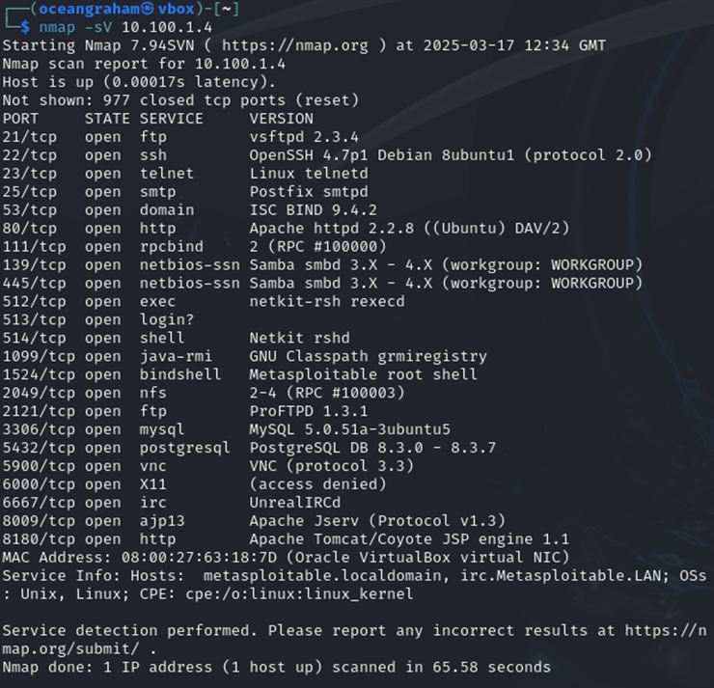

Figure 14 - Service Versions scan

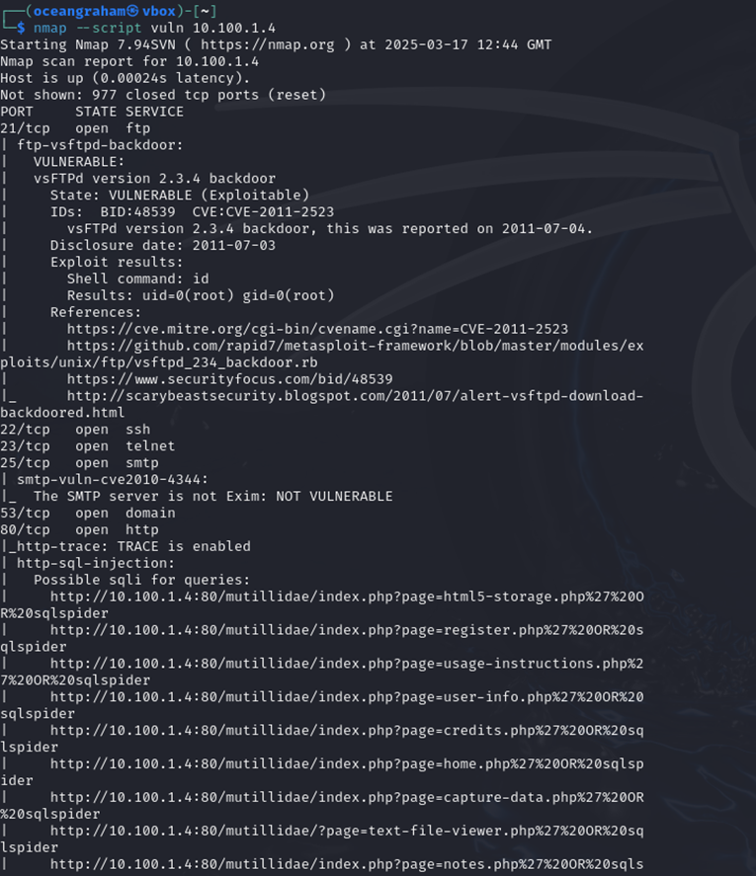Finally “nmap –script vuln 10.100.1.4” is used to find the vulnerabilities within the target system.

Figure 15 - Vulnerability scan 1

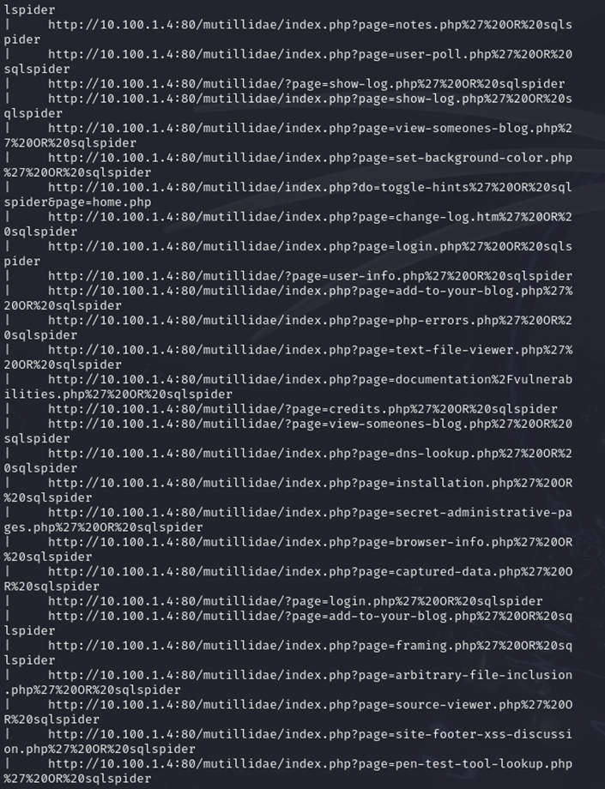

Figure 16 - Vulnerability scan 2

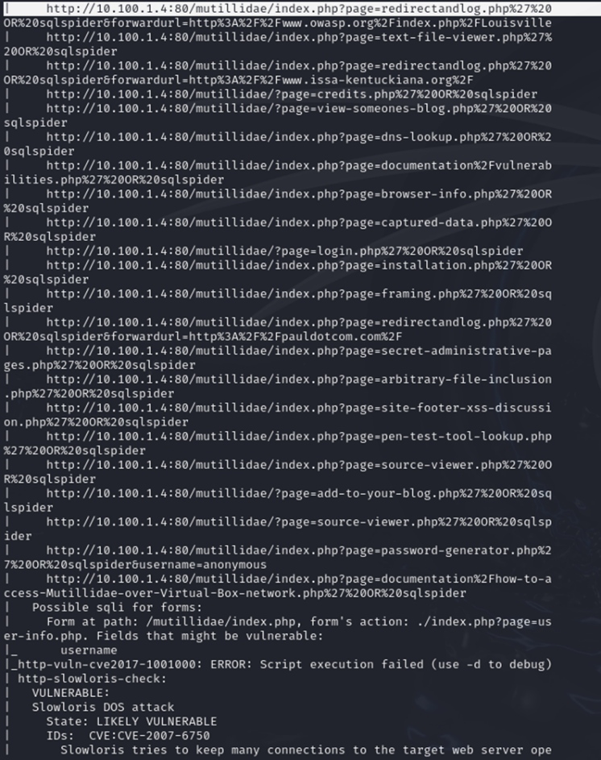

Figure 17 - Vulnerability scan 3

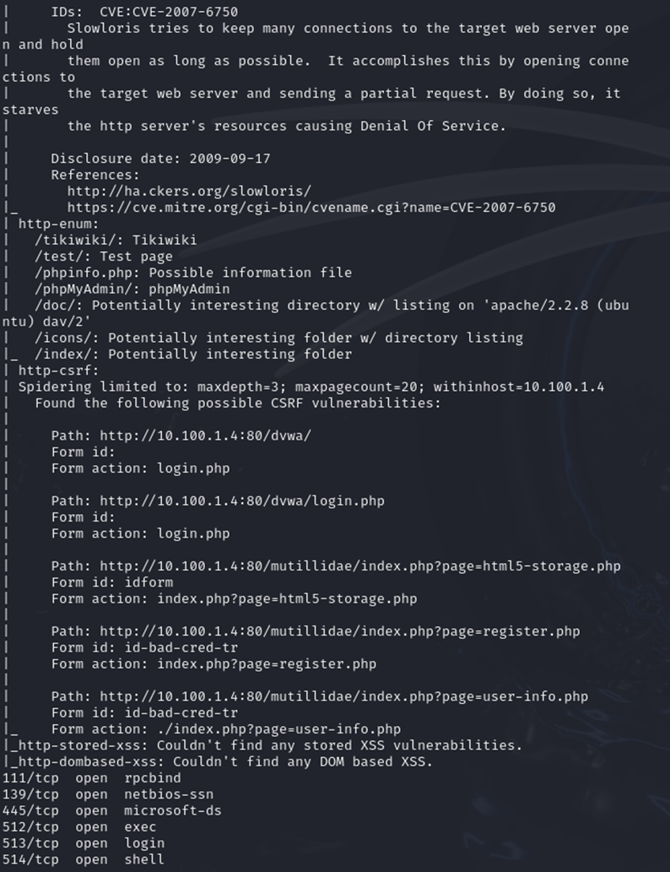

Figure 18 - Vulnerability scan 4

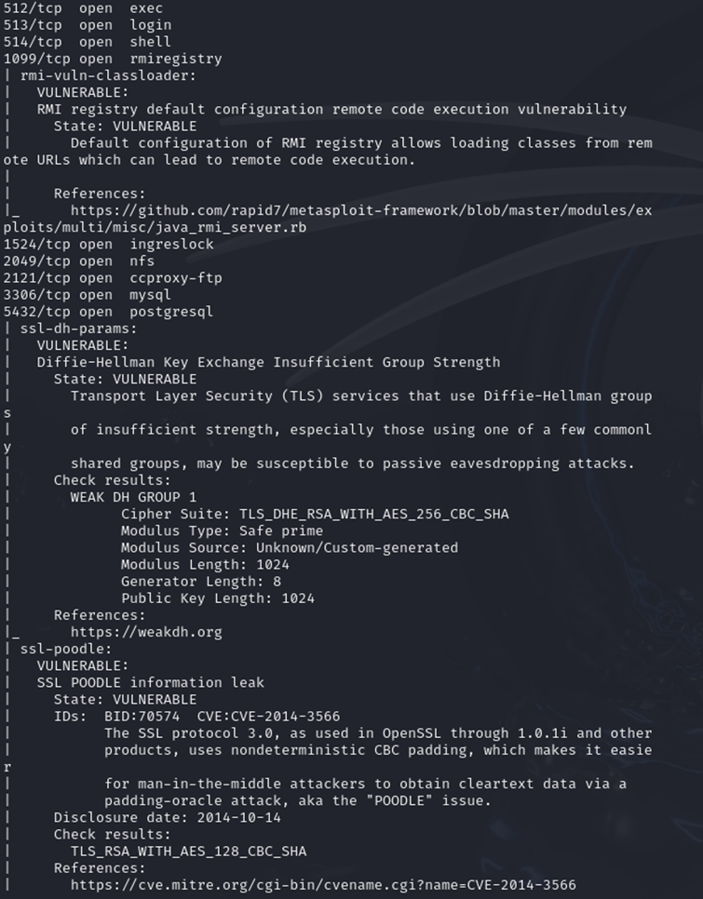

Figure 19 - Vulnerability scan 5

Figure - Vulnerability scan 5

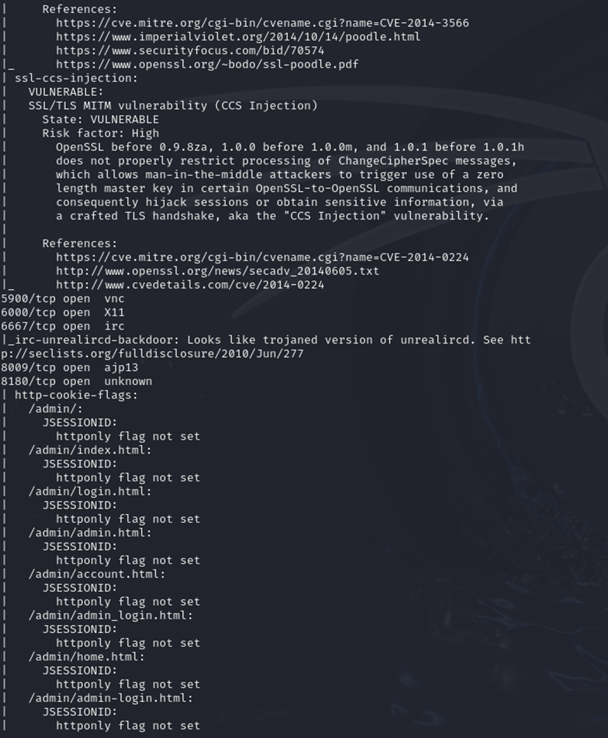

Figure 20 - Vulnerability scan 6

Figure - Vulnerability scan 6

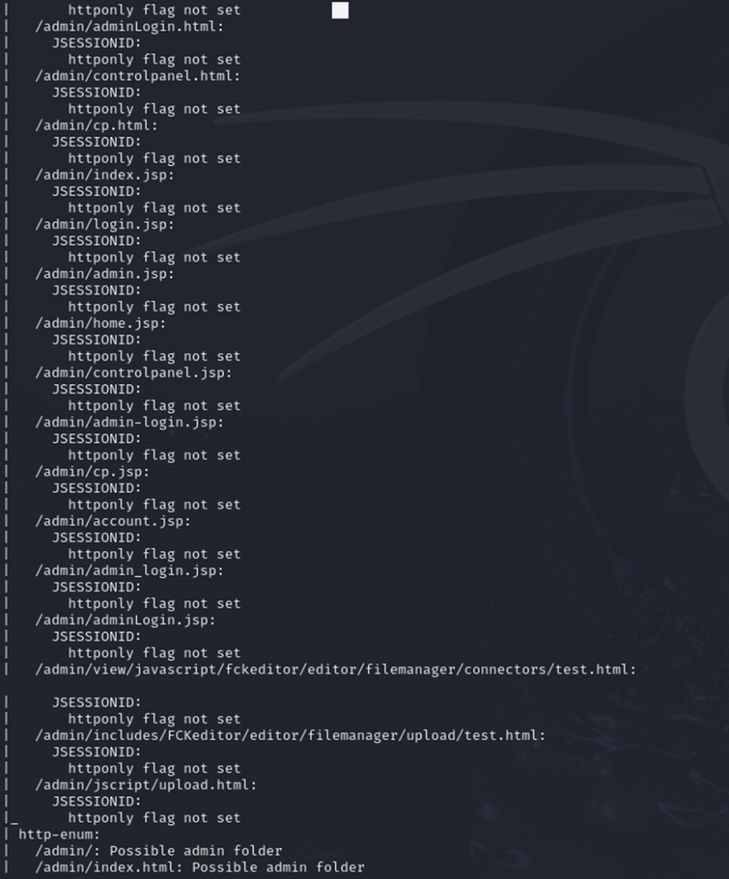

Figure 21 - Vulnerability scan 7

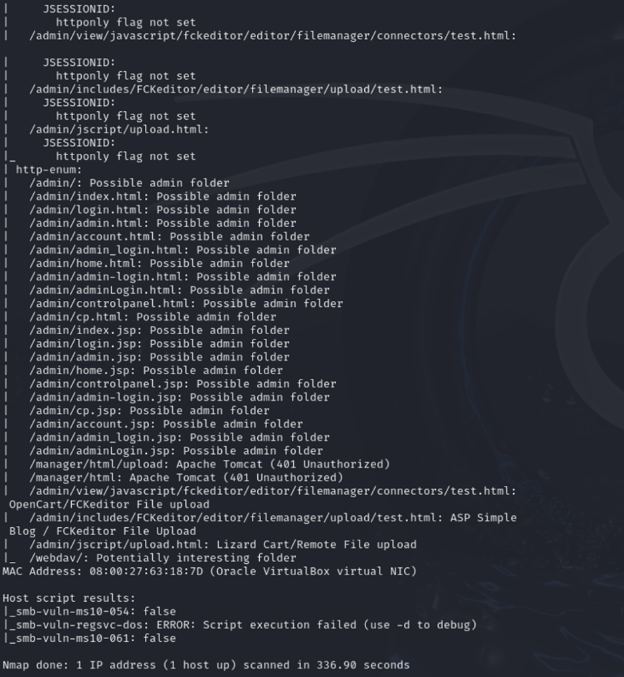

Figure 22 - Vulnerability scan 8

In the Metasploit experiment, we use Kali and Windows 7 as the systems, Windows 7 acting as the target of exploit to attempt to gain access to their system.

Firstly, with the Metasploit experiment we perform “ip a” and “ifconfig” to check the IP addresses of Kali and Windows 7

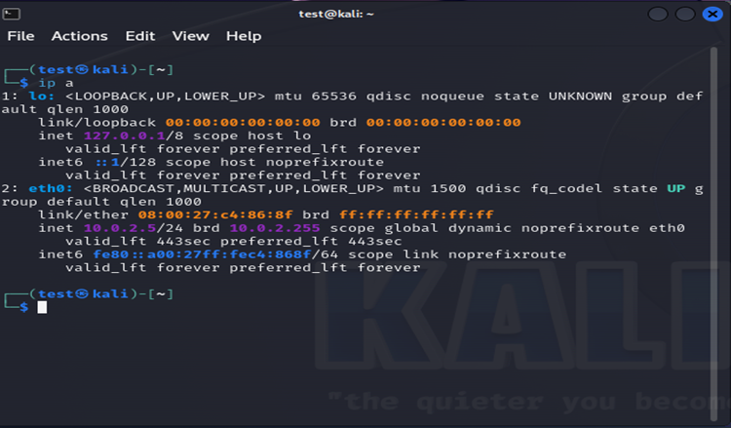

Figure 23 - Metasploit Kali IP scan

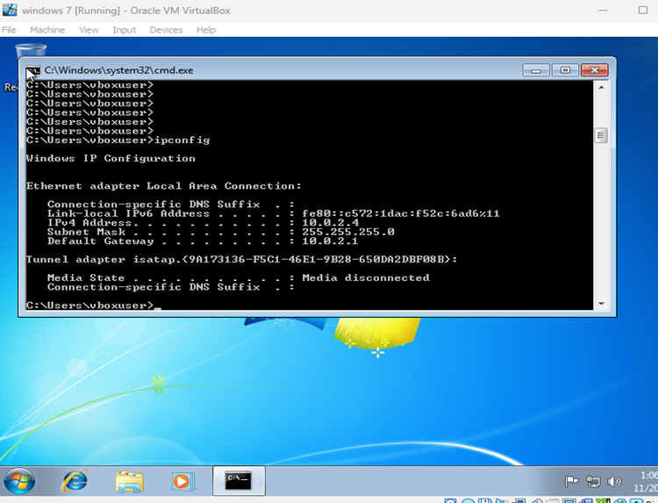

Figure 24 - Metasploit Windows 7 IP scan

Secondly, “sudo nmap -sV 10.0.2.4” is use to detect open ports and services, as said for experiment 1, this helps find vulnerabilities in the system that can be exploited. With this scan, we are looking for 445 to be open to exploit with a SMB-based exploit which works by “targeting specific vulnerabilities within the SMB protocol to gain unauthorized access or execute malicious code on a target system.” (*What Is an SMB Exploit? How It Works & Examples | Twingate*, 2024)

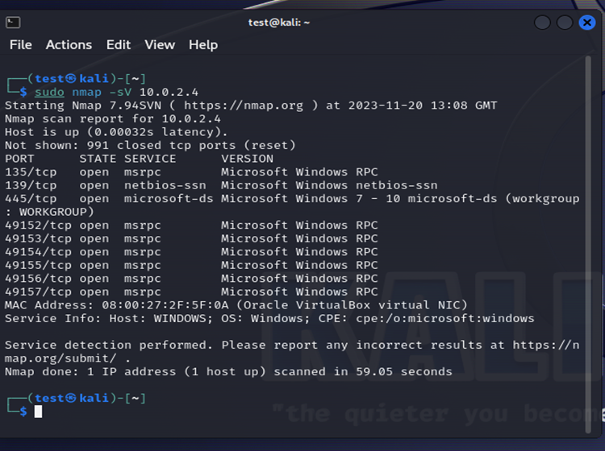

Figure 25 – Metasploit Service Version scan

Following this “sudo nmap –script smb-vuln* 10.0.2.4” is used to check the vulnerability in the target machine.

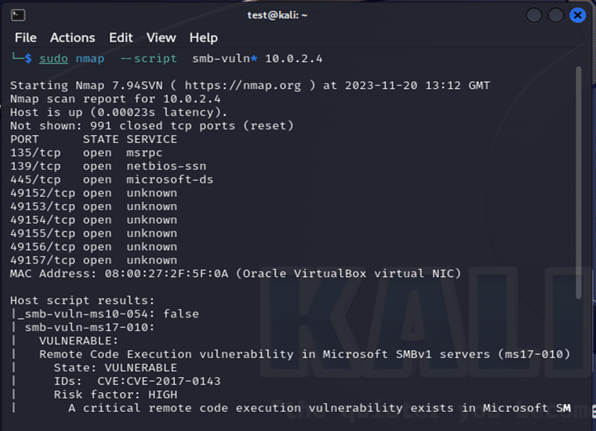

Figure 26 – Metasploit Vulnerability scan

Next Metasploit is opened using “msfconsole”.

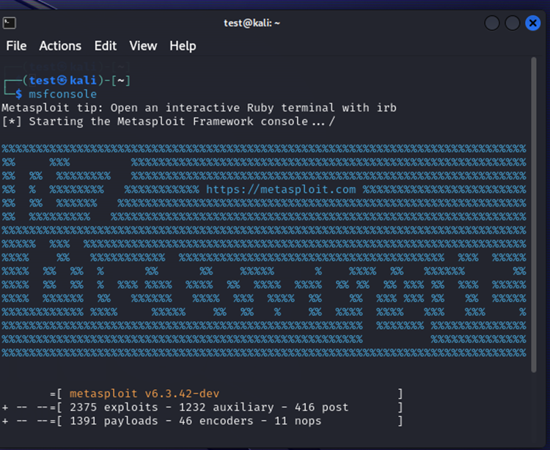

Figure 27 - Open Metasploit

Afterwards, EternalBlue/MS17-010 is searched for.

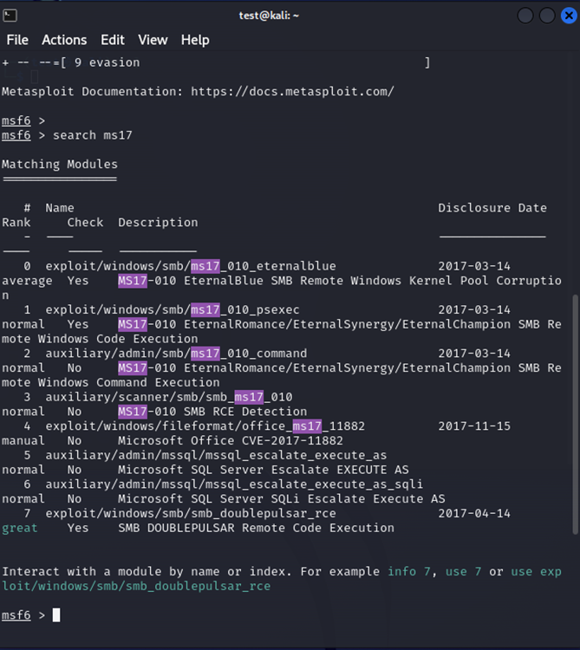

Figure 28 – Metasploit EternalBlue / MS17-010

“use 0” is input

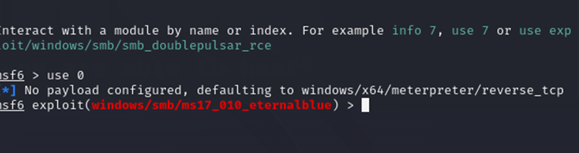

Figure 29 - Metasploit use 0 command

After this the exploit options are configured, the EternalBlue exploit is selected, “show options” is input to show all setting before an attack is pushed. As seen by figure 30, RHOSTS does not hold an IP address.

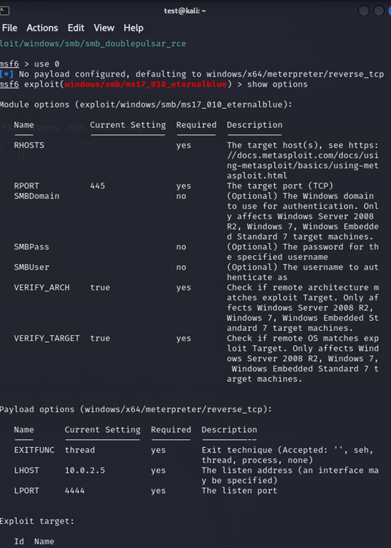

Figure 30 - Metasploit Exploit Option Config

The IP for RHOST is set via “set RHOSTS 10.0.2.4”

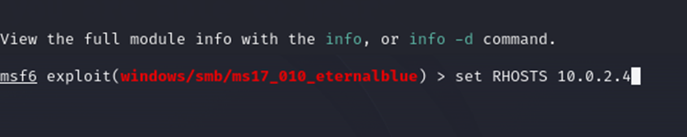

Figure 31 - Metasploit RHOST IP

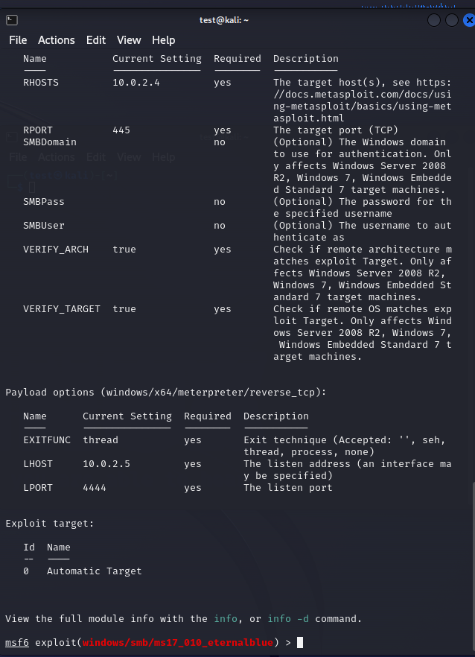

Figure 32 - Metasploit RHOST IP check

Finally, the exploit is ran via the “run” command. The exploit is checked if it is successful via “sysinfo” as seen in figure 33, the info of the system is not the Kali Linux info, but rather the Windows 7 info, showing that full access to the Windows system is within the Kali Operating system.

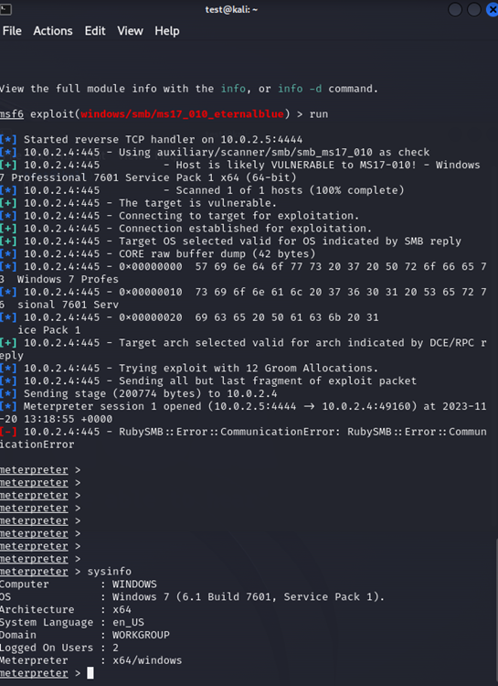

Figure 33 - Metasploit Exploit ran

### Phishing attack

With the phishing attack, Shellphish is used. Shellphish is an open-source phishing tool. It is going to be used as it contains templates for many popular media sites, in this case, facebook shall be used.

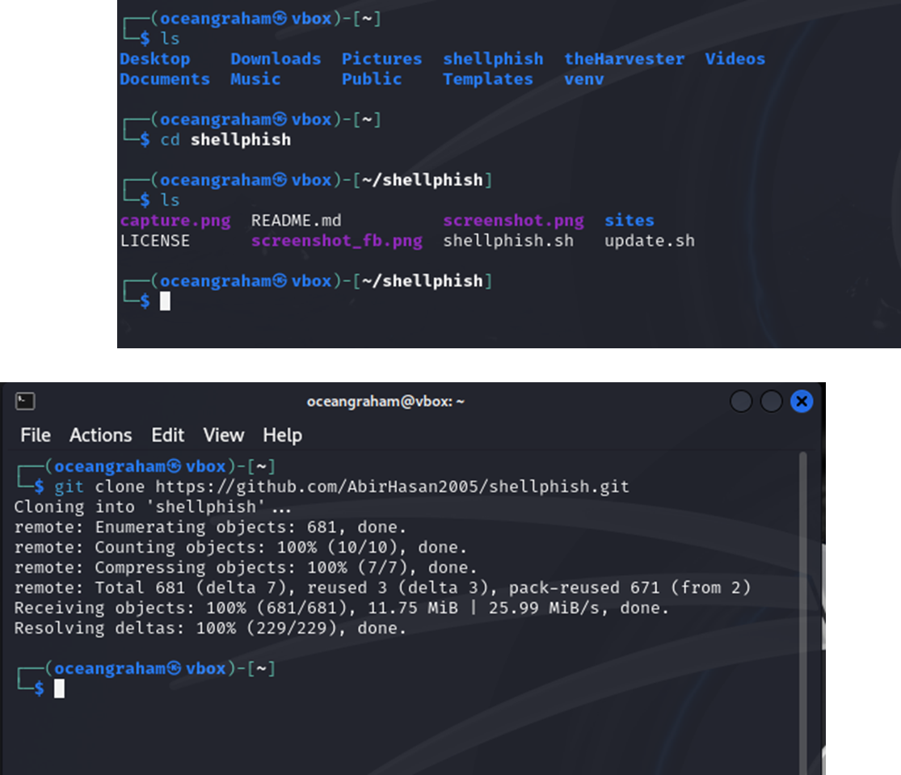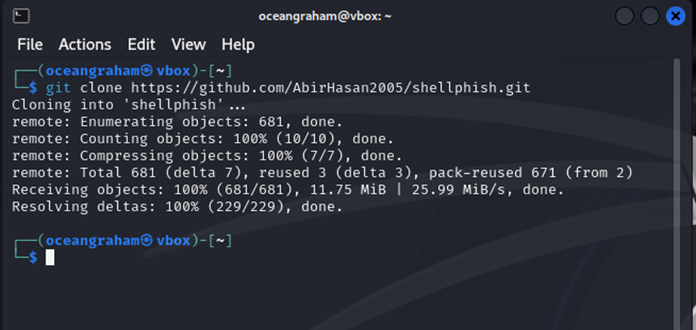Firstly, the github repository for the ShellPhish is install

Figure 34 - Shellphish Install

Figure 35 - ShellPhish location

Go into Shellphish

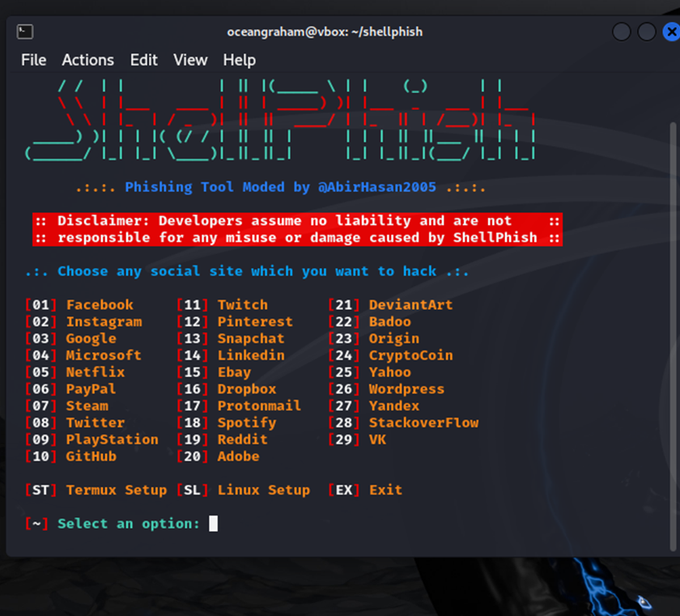

Figure 36 - Shellphish Open

=

Facebook is used as the practice website for the experiment. Here we set up the phishing link.

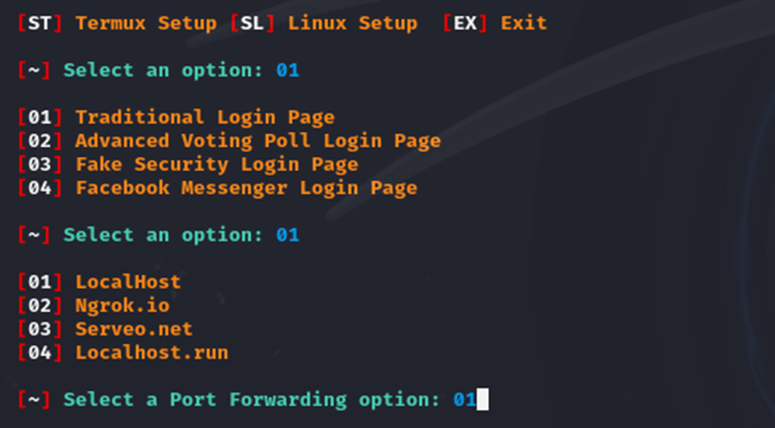

Figure 37 - ShellPhish Setup 1

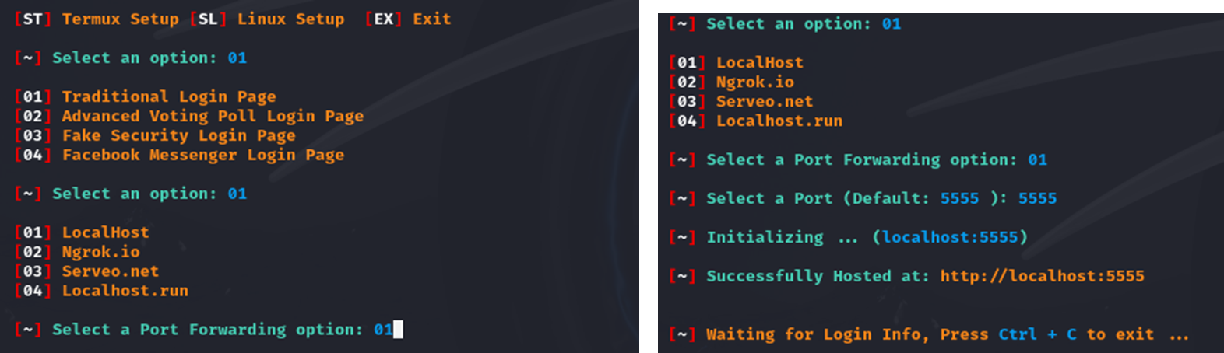

Figure 38 - ShellPhish Setup 2

Trialling the link to see if the phishing functions, when a login is input the phishing software takes the data input.

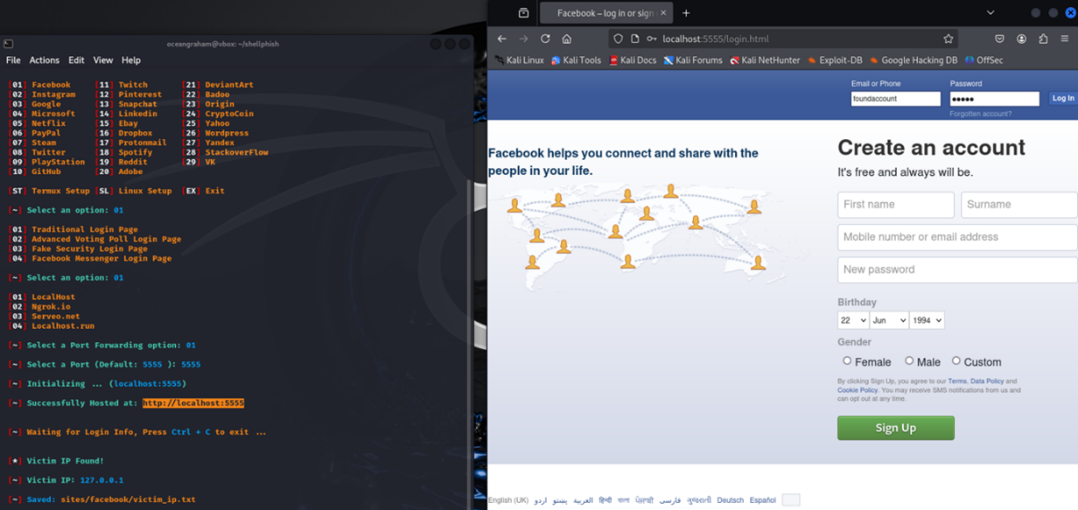

Figure 39 – Phishing Facebook Login

As seen, when a login is input, the data is taken and presented on the phishing software.

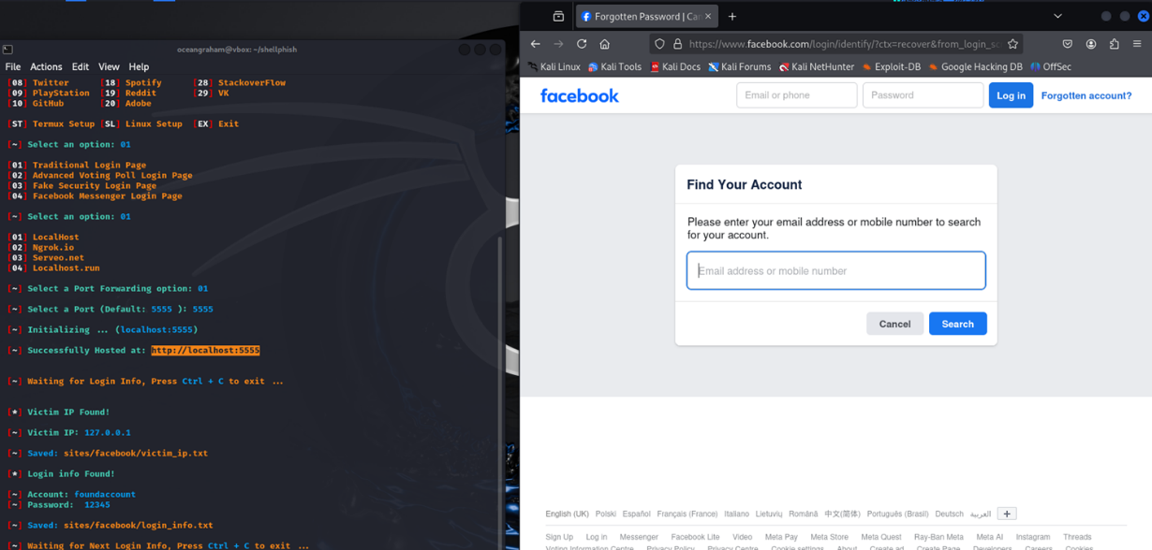

Figure 40 - Phishing Logins Taken

### SQL Map

This experiment involves SQL injections via the SQL Map open-source tool. This experiment is vital given the frequency of threat of SQL injections we can see in the tables (Figures 4, 5, 6, 7).

First we use a target test site (vulnweb.com)

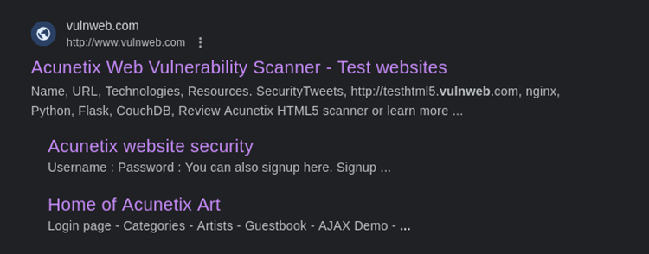

Figure 41 - SQL Test Site

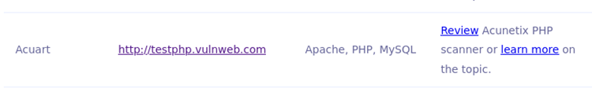

Figure 42 - Test Site onsite

A potential vulnerability has been found via the “artist=1” parameter.

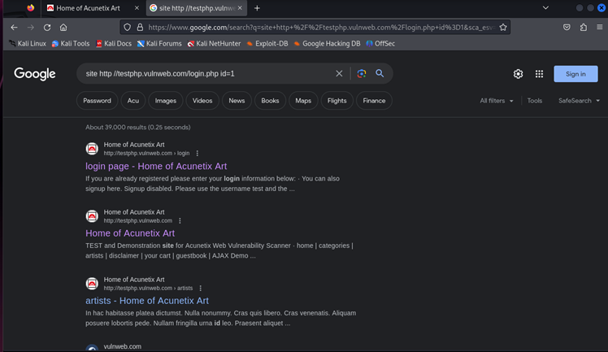

Figure 43 - Vulnerability Parameter 1

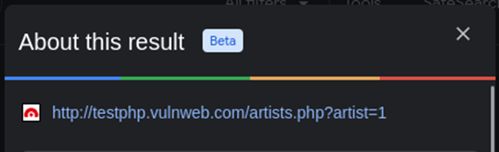

Figure 44 - Vulnerability Parameter 2

Next we run the SQL Map code “sudo sql map -u <https://testphp.vulnweb.com/artists.php?artist=1> –dbs” which performs a SQL injection into the login page, this should retrieve database information.

Figure 45 - SQL Map Code

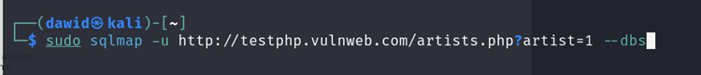

The command seen in figure 45 should outpul databases such as “acuart” and “information_schema”.

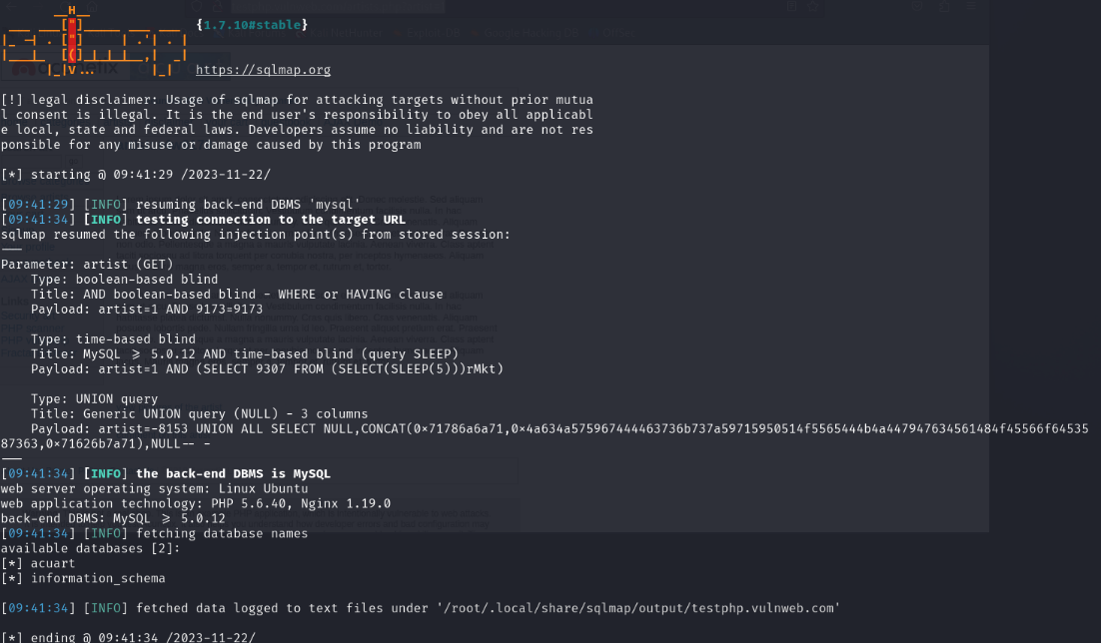

Figure 46 - SQL Map Output

Now that databases have been observed and there is awareness of there presence, a command to list the table of contents can be input to command.



Figure 47 - Database Elaboration Code

With this command, the tables within the acuart database have been shown. This command shows information in the “users” table such as name, address, username (uname), etc.

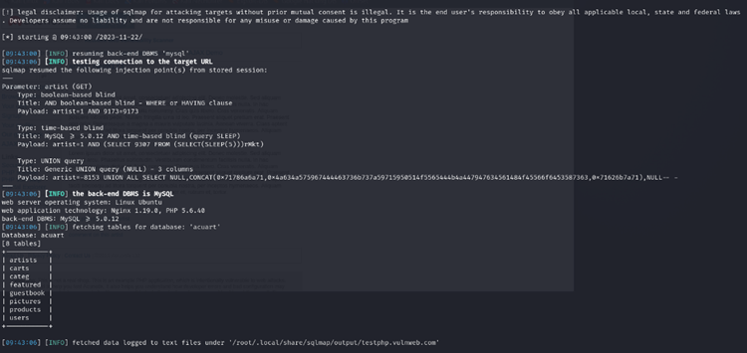

Figure 48 - Data Elaboration Output

Next we need to dump the data from the table to retrieve actual user data.

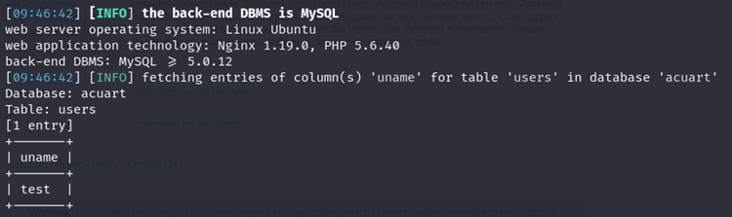

Figure 49 - Data Dump Input and Output 1

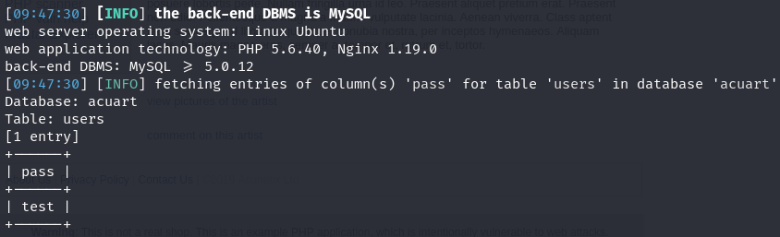

Figure 50 - Data Dump Input and Output 2

With these commands, access to usernames and passwords for the acuart website (as we dumped the acuart data) has been gained.

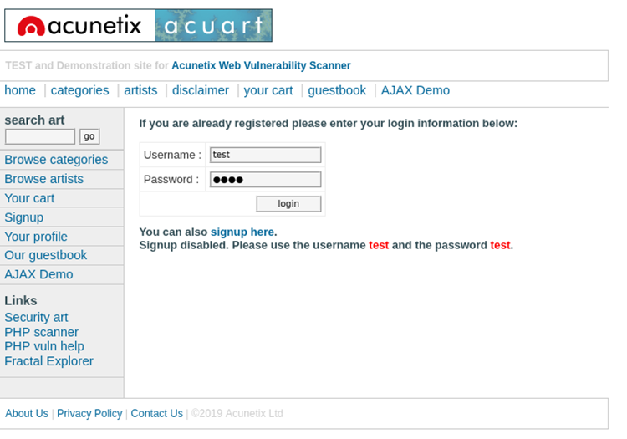

Figure 51 - Acuart Login

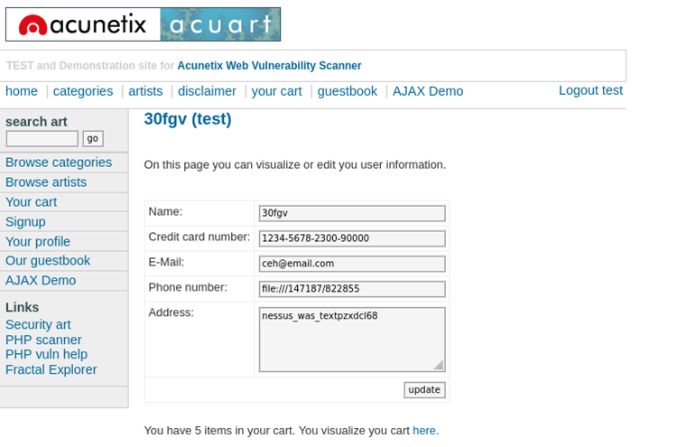

Figure 52 - Acuart Account details breach

## OpenVas

Figure 53 - Greenbone OpenVAS Logo

OpenVAS is a vulnerability scanner. This scanner performs “unauthenticated and authenticated testing, various high-level and low-level internet and industrial protocols (GreenBone, 2024)

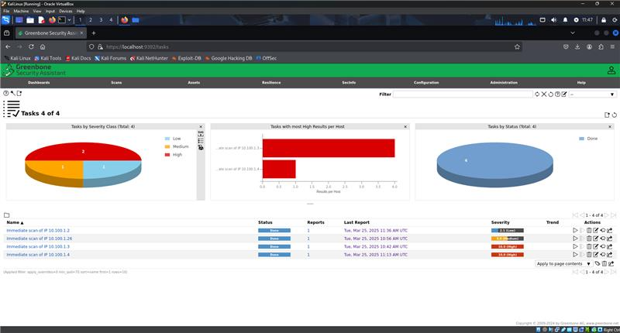This tool was used to give the tester detailed reports on the different operating systems that have been simulated within the Virtual Machine.

Figure 54 - OpenVAS Dashboard and Overview

### Ubuntu server Report

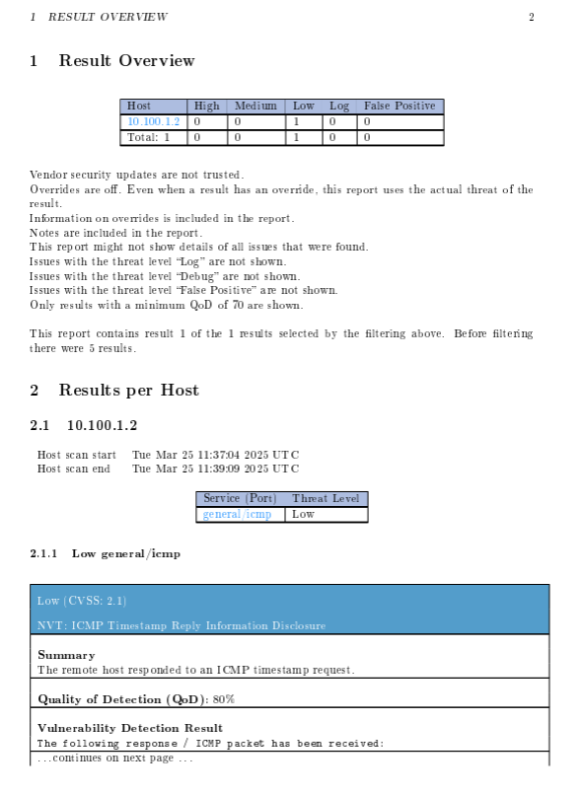

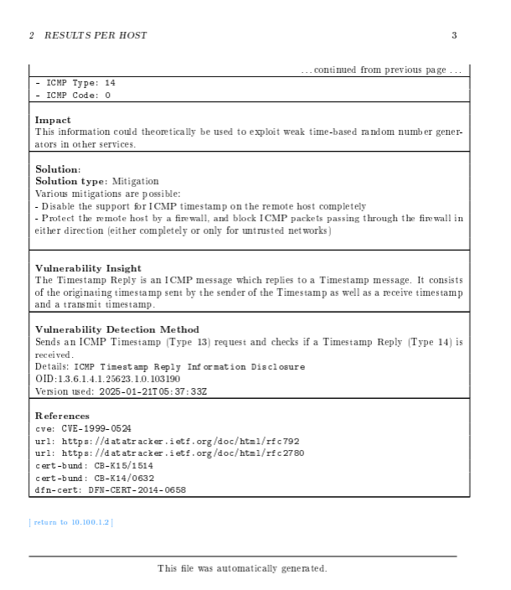

Internet Control Message Protocol (ICMP) is a protocol used primarily for error reporting, its secondary purpose is to perform network diagnostics. (Cloudflare, 2024, What is the Internet Control Message Protocol?)

The vulnerability of an ICMP Timestamp Request is a frequent low risk vulnerability. This request is an ICMP message that contains the timestamp of the device. The threat is that an attacker can request an ICMP Timestamp and know the time and date of your account. (Fortra, 2025, Finding and Fixing Vulnerabilities in ICMP Timestamp Request)

### Windows 10 report

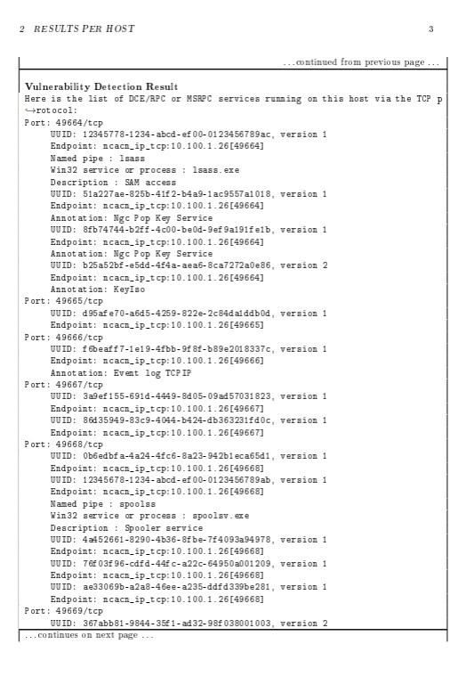

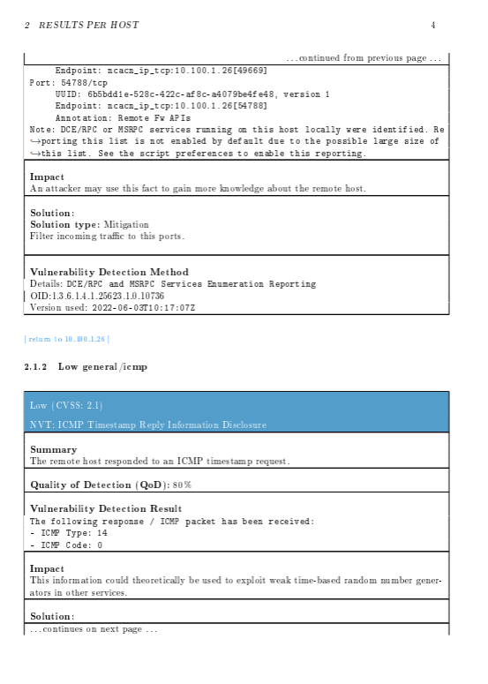

Distributed Computing Environment/Remote Procedure Calls (DCE/RPC) and Microsoft Remote Procedure Call are similar protocols that makes remote procedure calls. This means the call procedures (the process of invoking a function in a program, involving recalling a sequence (Cooper & Torczon, 2012)) can be initiated on a remote machine as different computers communicate and execute procedures.

The vulnerability of DCE/RPC allows attackers to gain unauthorised access, this risks an attacker being able to remotely execute code.

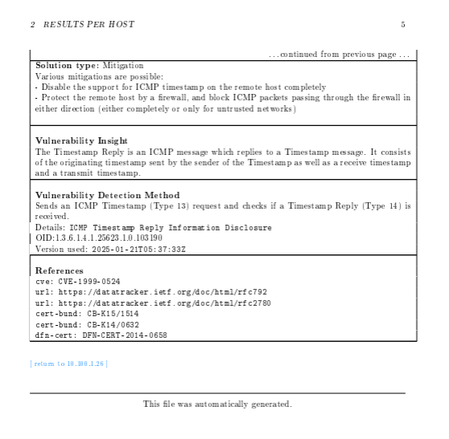

As said priorly in the Ubuntu Server report (Definition of ICMP as well) the vulnerability of an ICMP Timestamp Request is a frequent low risk vulnerability. This request is an ICMP message that contains the timestamp of the device. The threat is that an attacker can request an ICMP Timestamp and know the time and date of your account. (Fortra, 2025, Finding and Fixing Vulnerabilities in ICMP Timestamp Request)

### windows server 2016

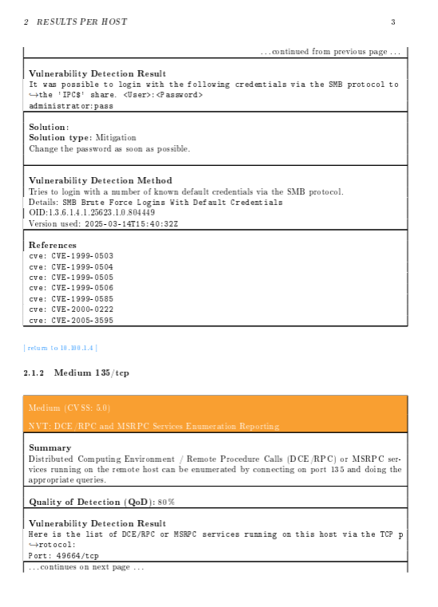

Server Message Block (SMB) is a network protocol that is used for shared access to resources on a network, it allows applications on a computer to edit files.

The vulnerability in SMB makes it possible to insert malware into a network, an example of such being EternalBlue as seen in the Metasploit experiment

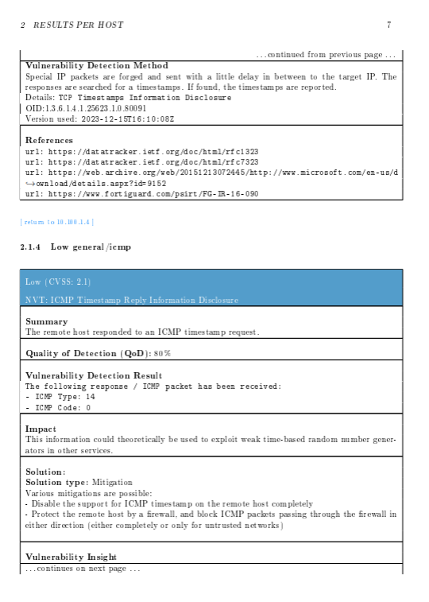

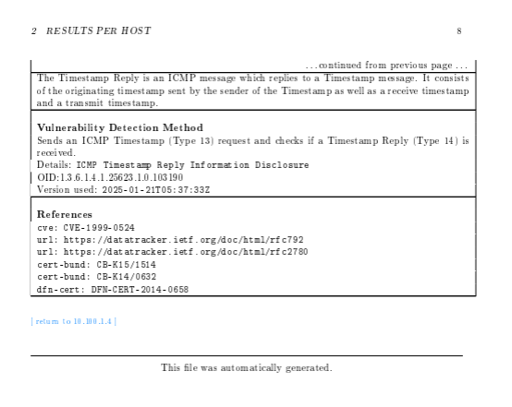

As said priorly in the Ubuntu Server and Windows 10 report (Definition of ICMP in Ubuntu report) the vulnerability of an ICMP Timestamp Request is a frequent low risk vulnerability. This request is an ICMP message that contains the timestamp of the device. The threat is that an attacker can request an ICMP Timestamp and know the time and date of your account. (Fortra, 2025, Finding and Fixing Vulnerabilities in ICMP Timestamp Request)

### Windows xp

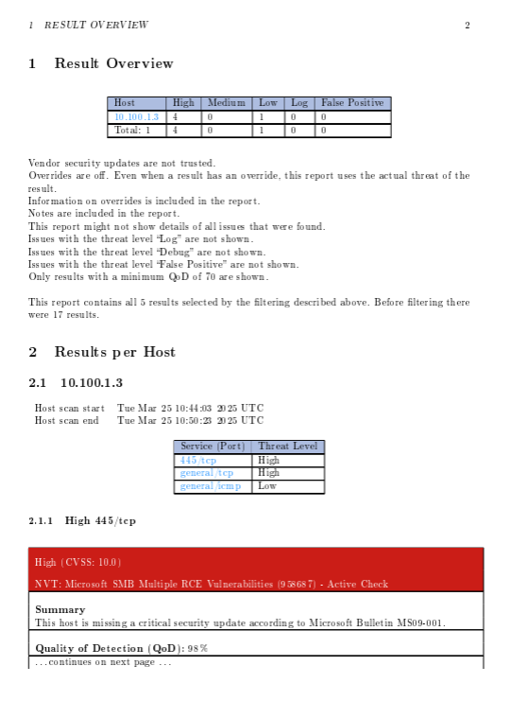

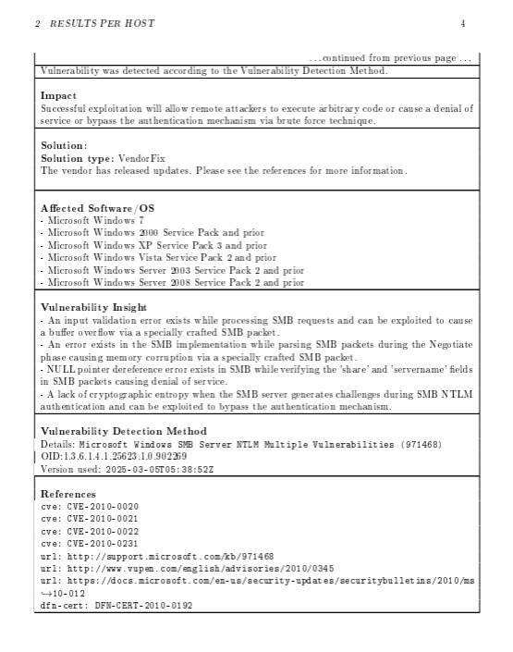

Server Message Block (SMB) is a network protocol that is used for shared access to resources on a network, it allows applications on a computer to edit files.

The vulnerability in SMB makes it possible to insert malware into a network, an example of such being EternalBlue as seen in the Metasploit experiment

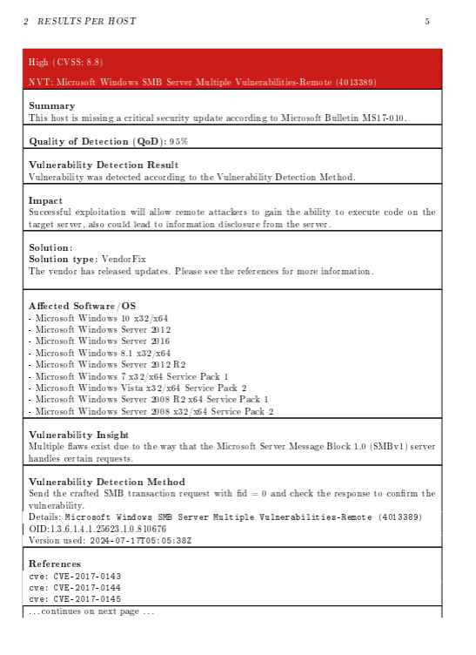

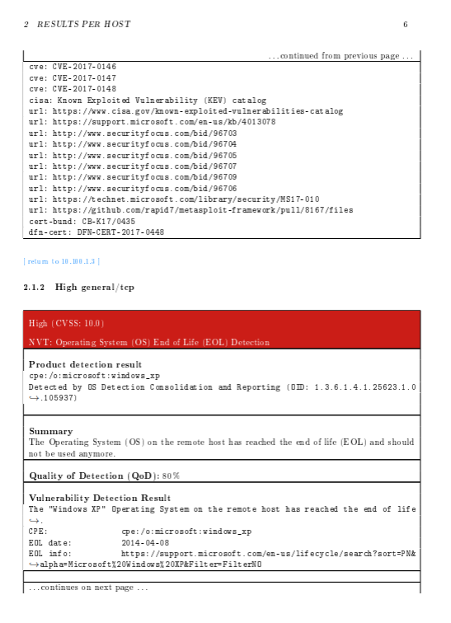

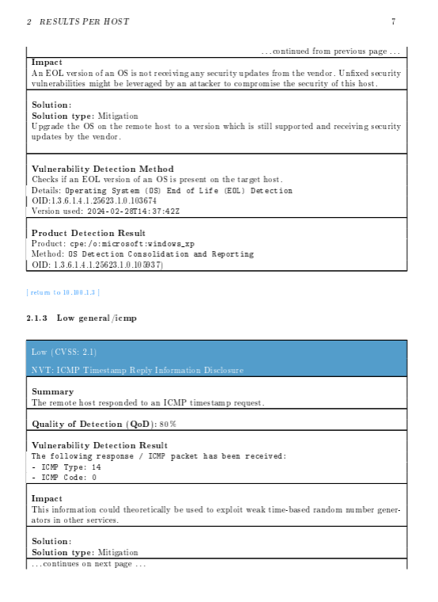

End of Life (EOL) is when a manufacturer stops supporting and patching the system, this creates a threat to security as it means threats will never be resolved and counter measured made to reduce risk.

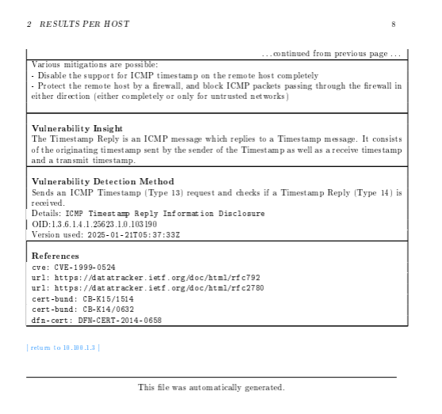

As said priorly in the Ubuntu Server, Windows 10 and Windows 2016 Server report (Definition of ICMP in Ubuntu report) the vulnerability of an ICMP Timestamp Request is a frequent low risk vulnerability. This request is an ICMP message that contains the timestamp of the device. The threat is that an attacker can request an ICMP Timestamp and know the time and date of your account. (Fortra, 2025, Finding and Fixing Vulnerabilities in ICMP Timestamp Request)

# Security Policies

Security Policies are a fundamental part of any subject relating to a organisation and it doesn’t differ with InfoSec. Security Policies within InfoSec are formal documents, guidelines, or rules that define the approach a company/organisation takes to protect its resources and Confidentiality, Integrity and Availability from threat.

There are many types of InfoSec Security Policies which can cover a varied range of matters, these are 4 examples of Security Policies that exist:

* Access Control Policies: This Policy consists of models where rules or a hierarchy of command are developed to decide who, where and/or what resources can be accessed and to what level can they be accessed. An example of such Policy is Discretionary Access Control (DAC), this model is specific that the owner/owners of a resource choose to grant privileges to others to access items in the system. This relies on the concept of Subjects (those who seek access) and Objects (A resource stored on a Network) (NordLayer, n.d., What Is Discretionary Access Control (DAC)?)
* Data Classification Policies: These policies consist of documentation, criteria or framework for outlining how organisation data is categorised and classified. This is usually based upon value, sensitivity, scope and requirements, these resources are then usually categorised into levels of sensitivity:

1. Public – available to the public
2. Internal – restricted to internal member in the organisation
3. Confidential – data restricted to internal members in an organisation but also requires an extra level of clearance to access
4. Restricted – accessible to only specific authorised personnel

* Password Policies: These policies are a set of rules and guidelines that specify password creation and management as to ensure stronger, more secure passwords which are more resistant against attacks such as brute-force attacks. These policies usually entail a suggested structure to how to create a password for the organisation (using different characters, numbers and special characters), an example of such being the NCSC recommendation of the 3 word rule (3 random words together) (National Cyber Security Centre, 2021). They usual also involve expiration dates, making users create a new password in a set frequency (e.g. every 30 days) and provide precaution against using similar passwords in history. All these rules are developed to reduce a organisations risk against attack, or if a breach occurs, the access gained is not as long lasting and damaging.
* Incident Response Policies: These policies are developed as a precaution the potential case of a breach. These come in the form of a framework or document that outlines how the organisation must act and what steps are taken for responding a security incident. These stages normally include:

1. Preparation – Planning and preparation for potential incidents
2. Detection – Identifying and analysis of the incident
3. Containment – Restricting and containing the incident as the reduce the spread and further damage and effect
4. Eradication – Elimination of the incident/threat
5. Recovery – Reparations and restoration of the systems to return the regular flow the organisation
6. Post-Incident Activity – Debriefing and observations from the incident (how it happened, what happened, how it was fixed and what can be done to reduce and stop a similar incident again.

# Conclusion

# References

Calder, A., & Watkins, S. (2024). *IT Governance – An international guide to data security and ISO 27001/ISO 27002, Eighth edition*. IT Governance Ltd. https://ebookcentral.proquest.com/lib/coventry/reader.action?docID=30281350&ppg=24&query=

Cloudflare. (2024). What is ICMP? | Internet Control Message Protocol | Cloudflare UK. *Cloudflare*. https://www.cloudflare.com/en-gb/learning/ddos/glossary/internet-control-message-protocol-icmp/

Cooper, K. D., & Torczon, L. (2012). Code Shape. *Engineering a Compiler*, 331–403. https://doi.org/10.1016/b978-0-12-088478-0.00007-4

Engebretson, P. (2011). *The basics of hacking and penetration testing : ethical hacking and penetration testing made easy*. Syngress. https://www.sciencedirect.com/book/9781597496551/the-basics-of-hacking-and-penetration-testing

*Finding and Fixing Vulnerabilities in ICMP Timestamp Request, a Low Risk Vulnerability*. (2025). Fortra.com. https://www.fortra.com/resources/vulnerabilities/icmp-timestamp-request

Fortinet. (2023). *What is the CIA Triad and Why is it important?* Fortinet. https://www.fortinet.com/resources/cyberglossary/cia-triad

GreenBone. (2024). *OpenVAS - OpenVAS - Open Vulnerability Assessment Scanner*. Openvas.org. https://openvas.org/

IBM, Holdsworth, J., & Kosinski, M. (2024, July 26). *Information Security*. Ibm.com. https://www.ibm.com/think/topics/information-security

ISO. (2022). *ISO/IEC 27001 standard – information security management systems*. ISO. https://www.iso.org/standard/27001

Kali. (n.d.). *Kali Tools | Kali Linux Tools*. Kali Linux. Retrieved March 26, 2025, from https://www.kali.org/tools/

National Cyber Security Centre. (2021, December 21). *Three Random Words*. Www.ncsc.gov.uk. https://www.ncsc.gov.uk/collection/top-tips-for-staying-secure-online/three-random-words

NIST. (2012). *Guide for Conducting Risk Assessments NIST Special Publication 800-30 Revision 1 JOINT TASK FORCE TRANSFORMATION INITIATIVE*. NIST. https://nvlpubs.nist.gov/nistpubs/legacy/sp/nistspecialpublication800-30r1.pdf

Pope, A. (2023, April 24). *Identifying risks and adopting risk-based thinking for ISO 27001 risk management*. Digital Octopii. https://digitaloctopii.com/blog/iso-27001-guide/identifying-risks-for-iso-27001/

Stamp, M. (2011). *INFORMATION SECURITY PRINCIPLES AND PRACTICE*. https://pdfs.semanticscholar.org/920a/10876a3bbf64110091f4001ecdd7bcc9f3f2.pdf

*What Is An SMB Exploit? How It Works & Examples | Twingate*. (2024, August 7). Twingate.com. https://www.twingate.com/blog/glossary/smb%20exploit

*What is Discretionary Access Control (DAC)?* (n.d.). Nordlayer.com. Retrieved March 27, 2025, from https://nordlayer.com/learn/access-control/discretionary-access-control/